Re-invigorating maternal, child and family health and

support services in Tjuntjuntjara

Project proposal and interim model of care
DRAFT 2022

INSERT SHS & PTAC LOGOS

Background

Paragraph describing Tjuntjuntjara geospacially, demographically and culturally. Since 2012 Spinifex Health Service, a business unit of Paupiyala Tjarutja Aboriginal
Corporation (PTAC), has held funding to deliver maternal and child health services to
the community. Over the last 10 years sources, amounts and associated deliverables of funding have varied, however the intent that members of the remote community have access to culturally appropriate, high quality child and family health services has remained constant.

Throughout Austrlalia organisations providing services in remote areas report difficulties with the recruitment and retention of appropriately skilled and qualified staff. PTAC and Spinifex Health Service are not immune to these challenges. As a result, and further complicated by the impact of COVID-19 there has been a lack of stability and suitably skilled staff to fill key positions associated with the provision of child and family health and support services in Tjuntjuntjara, particularly in the period 2021-2022. This has led to a devolution in previously utilised models of care and availability of support services available in the community.

Concurrently, a number of other changes, have, in the last five years, resulted in reported increases in the amount and frequency of alcohol and drug use in the community, volatile substance use and family and domestic violence. Indicating significant need for culturally safe services and support.

PTAC and Spinifex Health Service have identified the improvement of family and child health and support services as a key priority for 2023-2025. This document outlines key aspects of a proposed interim model of care and project to re-invigorate maternal, child and family health and support services in the community. The end-goal being
the development and implementation of a contemporary, co-designed, culturally safe model of maternal, child and family health and support services.

The interim model is based on models of care previously utilised in the community
that were developed through past community consultation. It is anticipated that the interim model of care can be appropriately resourced through current funding
streams. Additional funding will need to be secured to enable community and
stakeholder consultation and engagement required for co-design and potentially the resourcing of any additional positions and services required for the identified model of care.

Project description

Utilising co-design processes and informed by relevant health and community data, PTAC and SHS will work with the Tjuntjuntjara community and relevant stakeholders to develop a culturally safe, contemporary model of care for maternal, child and family health and support services to the community. Once developed the project will support implementation of the model and evaluation of progress and outcomes at identified timepoints.
Stage 1
Preparation
- Review of current
funding and develop project budget
- Review of data
- Stakeholder identification
Image 1: Co-design process
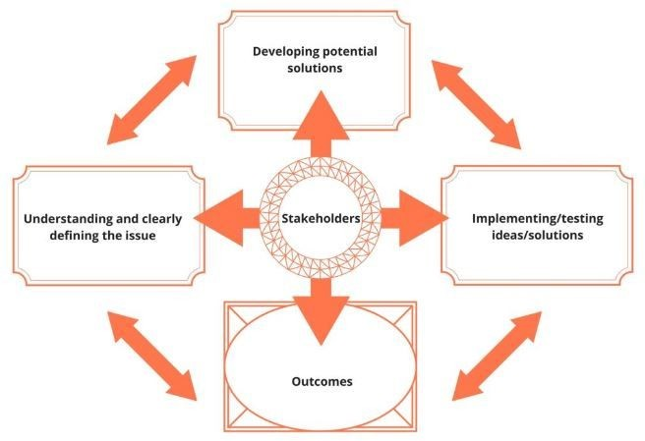
Source: NSW Council of Social Services, 2017

Project stages and timeline

It is proposed that the project will commence in January 2023 and be completed by January 2026. Six key stages have been identified, although stages and timeframes may evolve through the co-design process.
Image 2: Proposed stages and timeline

Stage 4
Implement & test
- Implement new model
- Ongoing stakeholder engagement for
feedback
2024
Jan-Dec

Stage 2
Stabilise & engage
- Recruit to key positions in interim model,
ongoing provision of care
- Commence stakeholder engagement
Stage 3
Define & develop
- Stakeholder engagement
- Define issues
- Develop model
- Identify resourcing opportunities
- Develop budget
Stage 5
Evaluate & improve
- Ongoing service delivery via new model
- Initial evaluation of new model
- Modify model as required
2022
Nov-Dec

2023
Jan-Dec
2025
Jan-Dec

Stage 6
Sustain
- Ongoing service delivery
- Ongoing stakeholder engagement
- Ongoing review and
modification based on CQI processes
Ongoing
3

Interim Model

Recognising the need to stregthen service delivery in the short-term to meet identified need PTAC and SHS are committed to reducing local operational silos and integrating the provision of family and child health and support services across the community.

As previously noted, the interim model is based on that which evolved out of community consultation to develop the initial funded child and family health service in the community in 2012 through OATSIH New Directions funding. It is anticipated
that investment in staff training and education will need to occur to operationalise the interim model, specifically around the provision of family and domestic violence
support and nutrition education.

Key role/positions associated with the interim model, role responsibilities, employment model and position funding are outlined in Image 4.

Image 4

Employment Responsibilities
- Universal and ECHS checks

Funding source

Child & Family Health Program Co-Ordinator
RN with Child Health Qualification

Child & Family Support Worker First Nations
community member

Women's Centre Co-ordinator Relevant Community
Development experience/quals
Interim model of care | Key roles

Midwife Kalgoorlie based qualified midwife

Remote Area Nurses
SHS clinic based

Program Implementation & Evaluation Project officer

0.6 FTE
- 2 weeks onsite
- 1 week off site (WFH)
- 3 weeks off with
- 1 day / week remote support WFH

Up to 0.6 FTE
- Casual/PPT
- May be more than one person
- May be AHW/AHP

1.0 FTE
- Community based position

Up to 0.2 FTE
- Casual/PPT
- Visiting support
- Kalgoorlie liasion
- May be outsourced

0.2 FTE
- Time allocation within SHS clinic arrangements

Up to 0.2 FTE
- Contracted/casual over 36 months
  - School health oversight
  - Oversight of 0-18's immunisation program
  - Advocacy and care co- ordination
  - Program team lead
  - Staff education & up- skilling

  - Community liasion , support & education
  - Promote program
  - Support visiting services

  - Nutrition education
  - FDV support
  - Playgroup facilitation in conjunction with school
  - Parenting support

  - Antenatal & postnatal checks
  - Oversight of antenatal patients
  - Advocacy and support
  - Education & upskilling

  - Immunisation program delivery
  - Assist with School health checks
  - Ear health program delivery
  - MBS 715 checks
  - Ill child care

  - Stakeholder consultation
  - Internal KPI development
  - System design/development
  - Staff education & onboarding
  - Project evaluation
  - WACHS Health Country Kids funding

  - WACHS Health Country Kids funding

  - Other PTAC funding

  - WACHS HCK funding
  - MBS revenue

  - WACHS HCK funding (0.1 FTE equivalent)
  - IAHP funding
  - MBS revenue

  - ? WACHS HCK funding
  - ?IAHP funding
  - ?MBS revenue

